# Introduction

This document and Processing sketchbook is designed to help the student install the processing programming environment and import the libraries needed to build the arcade game project. Once finished, the student’s PC will have installed the Processing run-time and support libraries needed to complete the project.

Each of the following sections describes the installation of a needed library ending with the execution of the test program which utilizes each of the installed libraries. The last section uses the program gameLibraryCheck.pde to demonstrate that the installation is correct.

This installation has only been tested on Windows 7 & 10. Processing itself will also run on OSX and Linux, but I am not certain that the three libraries needed to build the game have been ported to these two platforms. I believe that the same procedure will be followed, so you are free to try and see for yourselves.

## Install Processing

Installing processing is simple. Download the zip file for your platform from ‘processing.org’. Open and unpack the zip archive into a target directory. I suggest C:\ but that is up to you. In the Processing directory you will find the executable that starts the Processing IDE. Start the IDE to make sure it is working before proceeding. The slides “Introducing Processing” on the eLearning site provide a bit more detail into the installation.

## Install the Test Program

In this step, you will copy the test program and install the test program onto your PC to allow configuration and testing of the needed Processing installation.

Copy the zip archive ‘gameLibraryCheck.zip’ file from eLearning to your PC. Unpack the archive into a folder of your choice e.g. desktop, myDocuments, etc. You can start the program by double clicking the PDE file. The IDE should load the program, but there will be many compile errors because the three needed libraries have not yet been installed.

## Install the Minim Library

Once you have Processing installed and running, you should install the Minim library. Minim is the Processing library which provides sound output capabilities (as well as other sound-related services).

1. Open the Sketch>>Import Library>>Add Library menu. This should bring up the “Contribution Manager” GUI.
2. Type “minim” into the manager’s search bar. This should limit the libraries displayed in the panel. The following figure shows what to look for.
3. Select Minim and press “Install” at the bottom of the panel. This should download and install the library.

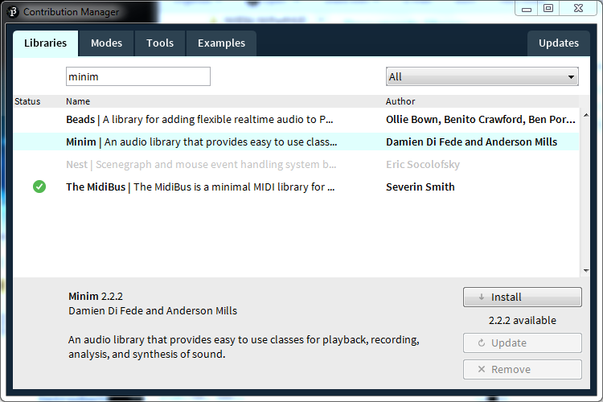

## Install the Sprites Library

<http://www.lagers.org.uk/s4p/index.html>

Next you will install the Sprites library. Sprites is the Processing library which provides the ability to draw and manipulate sprites on a Processing canvas. Do some research into what Sprites are on the web.

1. Open the Sketch>>Import Library>>Add Library menu. This should bring up the “Contribution Manager” GUI.
2. Type “sprite” into the manager’s search bar. This should limit the libraries displayed in the panel. The following figure shows what to look for.
3. Select Sprites and press “Install” at the bottom of the panel. This should download and install the library.

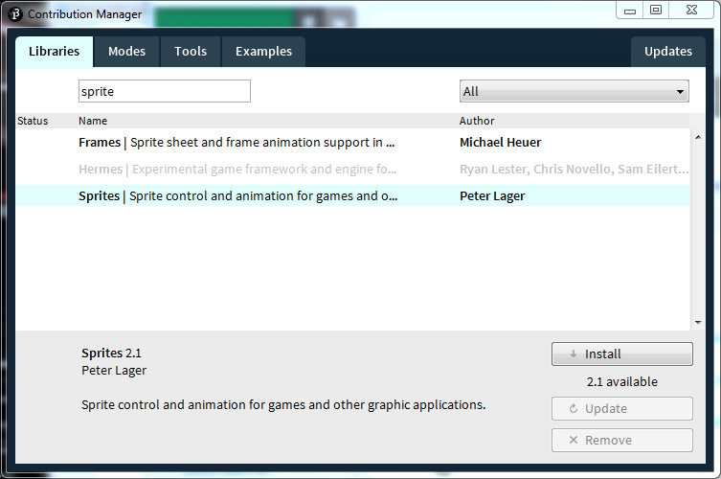

**The current version of Sprites is 2.1.1**

## Install the Game Control Plus Library

<http://www.lagers.org.uk/gamecontrol/index.html>

Next you will install the Game Control Plus library. GCP is the Processing library that provides access to the keyboard keys in a manner that resembles a game controller. If you are interested, the library also allows the use of PS3 and Xbox controllers in your Processing programs running on a PC and interfaced though a USB port.

1. Open the Sketch>>Import Library>>Add Library menu. This should bring up the “Contribution Manager” GUI.
2. Type “plus” into the manager’s search bar. This should limit the libraries displayed in the panel. The following figure shows what to look for.
3. Select “Game Control Plus” and press “Install” at the bottom of the panel. This should download and install the library.

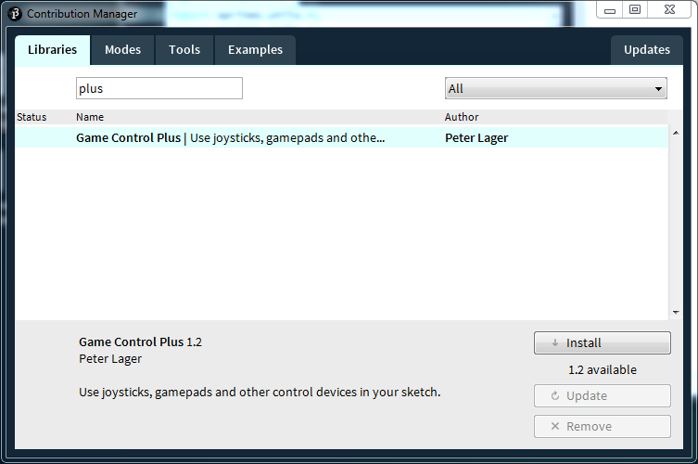

The current version of GCP is 1.2.1

## Changes Needed for OSX

To get both the test program, and the game itself, working on Apple’s OSX you need to make the following changes.

1. Line 29: Instead of using the string “Keyboard”, use “Apple Internal Keyboard / Trackpad”.
2. Line 30: Instead of using string “Space”, use a literal space “ “.

After making these changes, some students using Macs needed to reboot their PC to get the desired result.

The sketchbook in “GCP_ShowDevices.zip” contains a program that will print the devices and keyboard maps for the target PC.

## Run the Test Program

1. After you have installed all three libraries, exit Processing to reinitializing the loaded libraries.
2. Restart Processing by double clicking the provided “gameLibraryCheck.pde” program in the sketchbook folder you installed earlier. You may need to use the “open with…” feature of Windows to select the Processing executable.
3. In the Processing IDE, press the Run icon to start the program running. This will open a new window with a ‘ship’ in the bottom center. The following figure shows what to expect.
4. Test your Processing installation as follows:   
    The left and right arrow keys will move the ship left and right.   
    The space bar will trigger a ‘popping’ noise.

Feel free to look over the program to see how these libraries work. Look over the documentation found at the provided links to better understand. There are many animation options provided by the Sprites library you may want to utilize in your team’s game.

